Instructions

**Table of Contents**

**INTRODUCTION:**

The Visual Studio Code (VSCode) software is a source code editor made for Windows, Linux and macOS. It includes support for debugging, embedded Git control, syntax highlighting. The intended use of VSCode is a general-purpose code editor, but it has specific support for web development and programing.

This instruction manual helps users of any level to customize VSCode to their liking. VSCode allows custom themes, fonts, and more to help users personalize their

In this manual, you will learn … You can … You can …

**Change the Theme in Visual Studio Code**

A theme is … [definition] . To change the theme,

1. Text

   Description automatically generatedClick **Extensions** in the left-hand menu
2. Type a theme in the **search box**

*Note: You can type …. Examples …*

1. Click the desired **theme**
2. Click **Install**

1. Click ~~on the~~ **Set Color Theme** ~~button~~

Changing the Font in VSCode

**Overview**

Changing the font in VSCode can help improve readability of code. A custom font combined with Ligatures standout. There are two steps to change font and enable Ligatures:

**Step 1: Change Font**

1. Click **File**

1. Click **Preferences > Settings** in the drop down menu

1. Click **Text Editor**

1. Click **Font** in the drop down menu under Text Editor

1. Enter your desired font in the **Font Family** box

**Step 2: Enable Ligatures**

**Warning:** **Changes made in the settings.json file could cause potential issues, please proceed with caution**

1. Click **Edit in settings.json** under the Font Ligatures section

1. Replace “editor.fontLigatures” value from **false** to **True**

Connect MySQL to VSCode

Overview

By pairing MySQL with VSCode, SQL queries can be executed in VSCode. By running queries in VSCode, extensions and themes are applied. There are 3 steps to connecting MySQL and a necessary software:

Microsoft SQL Server Management Studio

Steps:

1. Install the MySQL extension
2. Create a database
3. Connecting the database to Visual Studio Code

Step 1:

1. Click on the **Extensions** icon in the left-hand menu

1. Enter “mysql” in the **Search Box**

1. Click the **Install** button

Customize Terminal:

1. Click the **Gear Icon** on the bottom right



1. Click **Settings** in the drop down menu

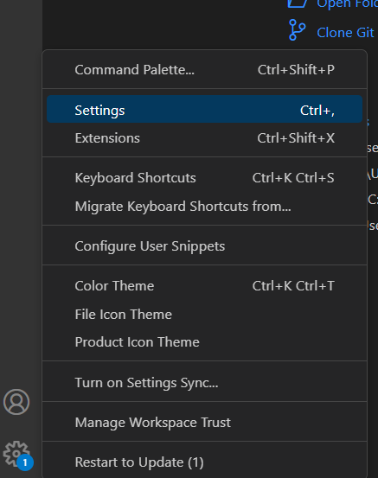

1. In the Search box type in **Color Customization**

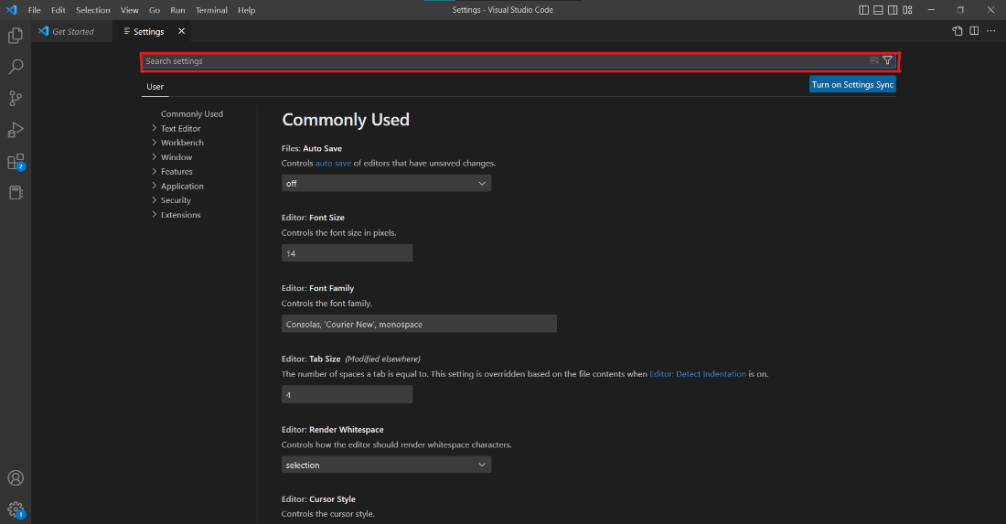

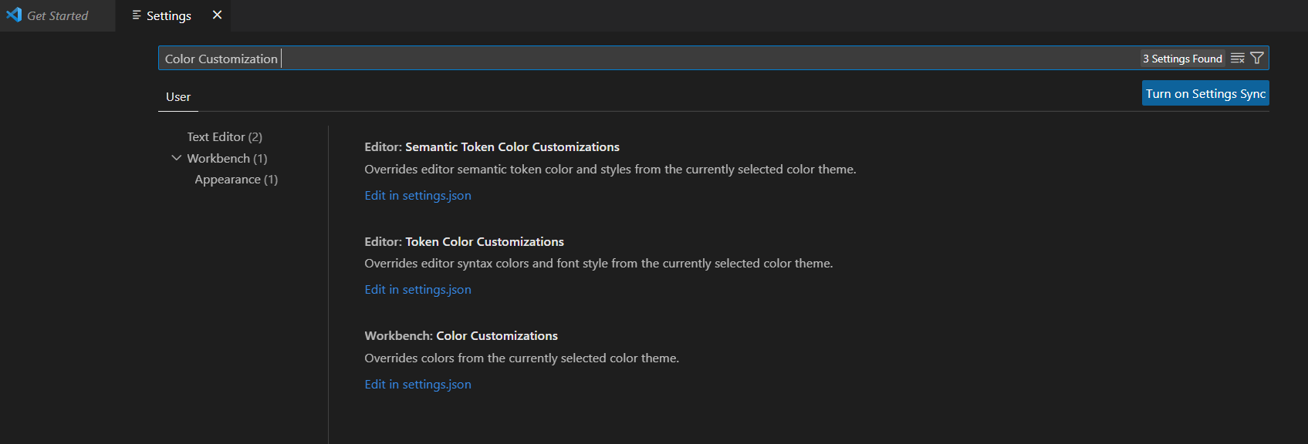

1. Click **Appearance** Option

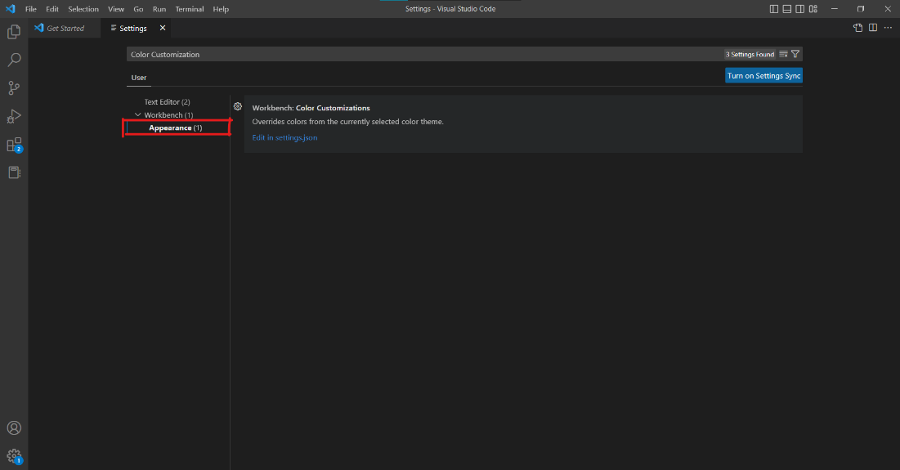

1. Click **Edit in settings.js**

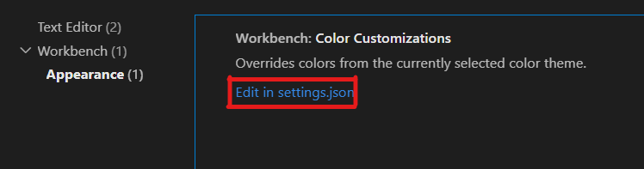

1. Paste desired color pallet under workbench.colorCustomizaions:

